java versions paths in linux
ls/user/lib/jvm.

Java uninstall process in linux :
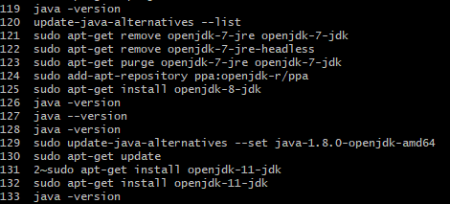
How to uninstall maven in linux ubuntu

How to install jdk maven tomcat in linux ubuntu
First install the jdk new version

Check java version
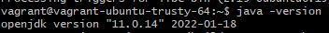

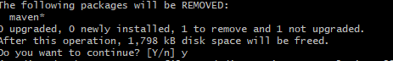
Install maven
@vagrant-ubuntu-trusty-64:~$ wget --no-check-certificate https://dlcdn.apache.org/maven/maven-3/3.9.8/binaries/apache-maven-3.9.8-bin.tar.gz

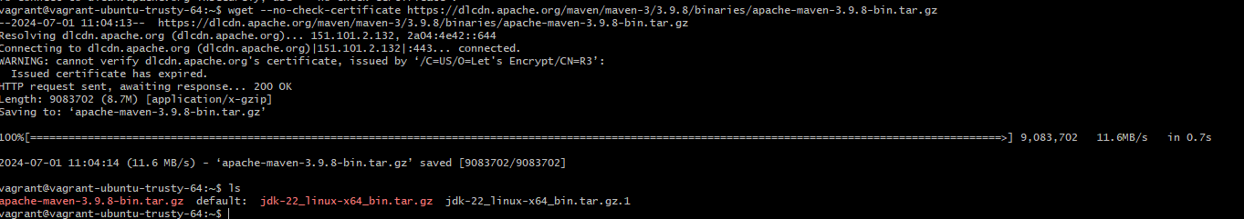
Check maven are there or not
Next
Next

Do the exporting
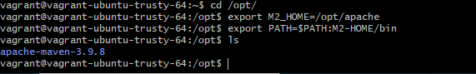

Next
Cd / do this command and ls also
Go to the tomcat select the new version then install it
Sudo wget –no-check-certificate https://dlcdn.apache.org/tomcat/tomcat-9/v9.0.90/bin/apache-tomcat-9.0.90.tar.gz
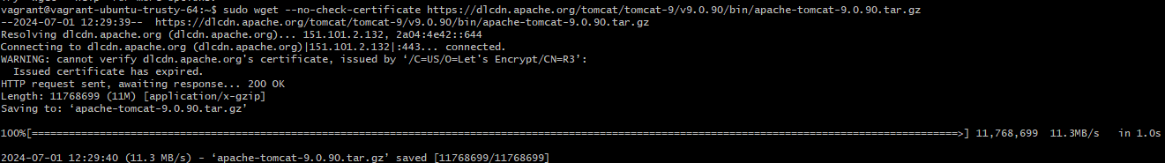
Next
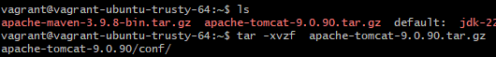

Next
Extrat tomcat
Sudo tar -xvzf apache-tomcat-9.0.90.tar.gz -C /opt/

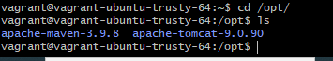
next
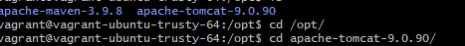
Next go to the cd conf/ after enter this command in this said we have one tomcat-user.xml file go the that tomcat-use.xml end edit the code
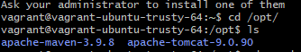
This is tomcat -user.xml file

sudo yum install java-1.8.0-amazon-corretto-devel
y
java -version
sudo yum install -y apache-maven
mvn -version
ls
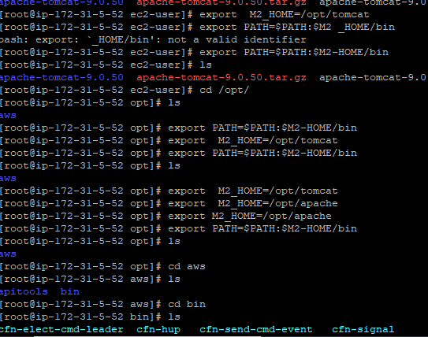
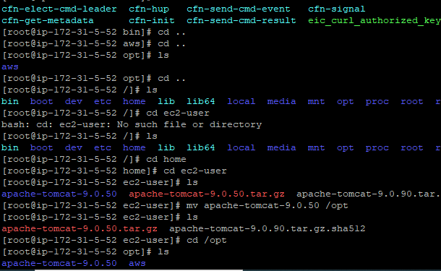
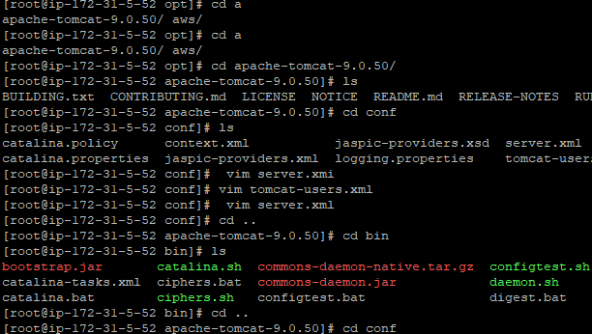
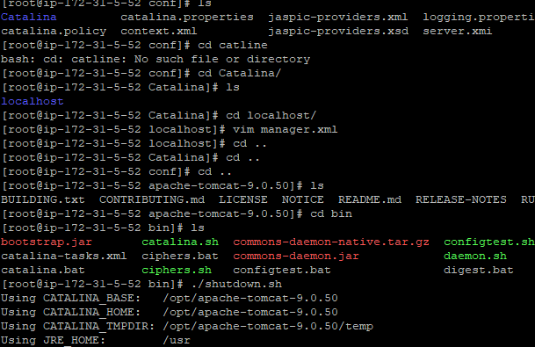

sudo tar xvf apache-maven-3.9.0-bin.tar.gz -C /opt
export M2_HOME=/opt/maven export PATH=${M2_HOME}/bin:${PATH}

tomcat
wget https://dlcdn.apache.org/tomcat/tomcat-9/v9.0.55/bin/apache-tomcat-9.0.55.tar.gz
tar -zvxf apache-tomcat-9.0.55.tar.gz
export M2_HOME=/opt/tomcat
export PATH=$PATH:$M2 _HOME/bin

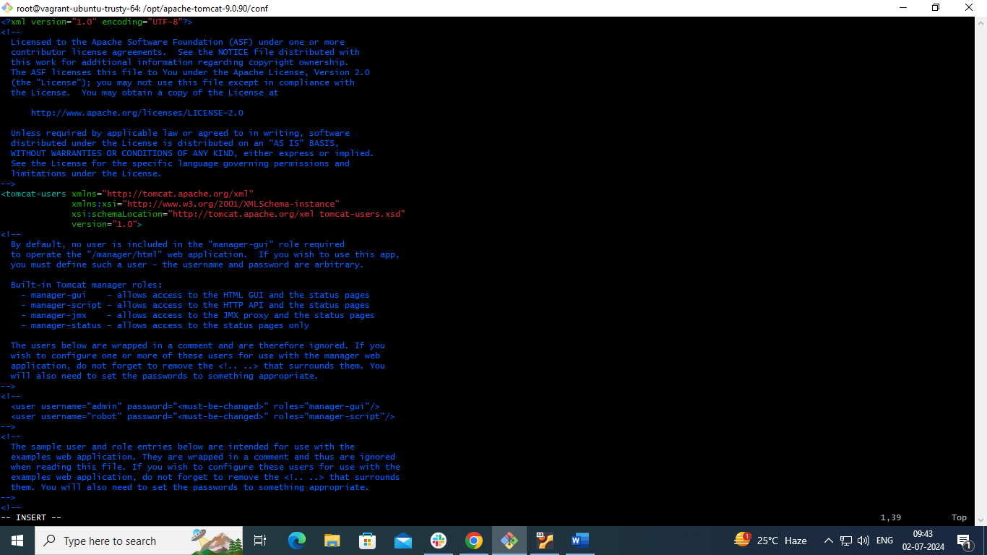
In this last enter the this code
<?xml version="1.0" encoding="UTF-8"?>
<tomcat-users>
<role rolename="manager-gui"/>
<user username="tomcatmgr" password="tomcatmgr" roles="manager-gui"/>
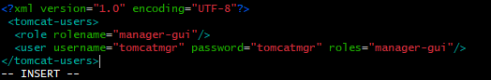
Then save the code
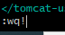
Next cd .. and ls enter
Go to the cd bin/ and ls
Then enter the ./shutdown.sh
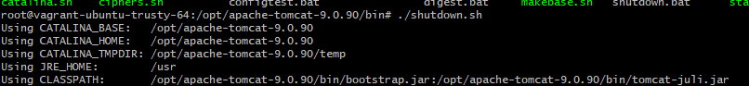
Enter the ./startup.sh
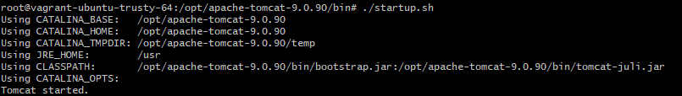

Cd /opt/tomcat…./conf
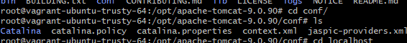
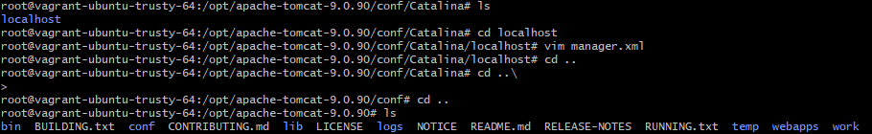

step
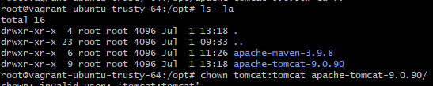

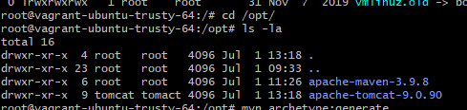

Edit file
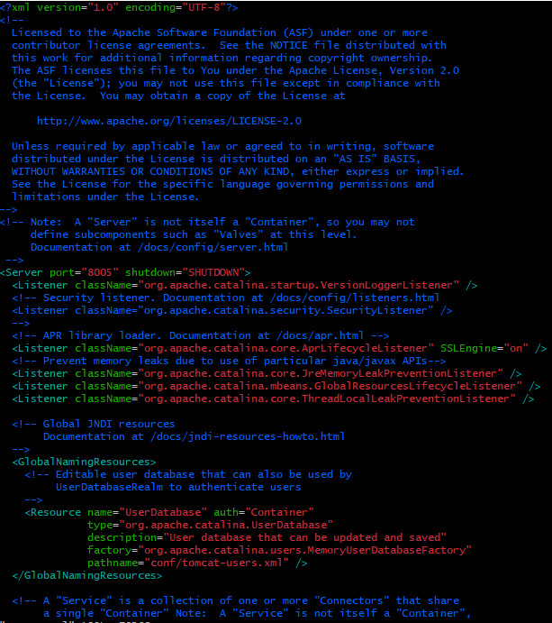
Change the port number and save
1, shift : 2 wq! Then enter
